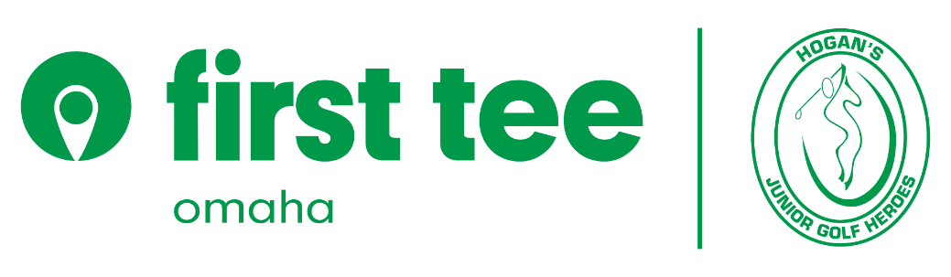

2022
Hogan’s Junior Golf Heroes DBA First Tee - Omaha Summer Programming
DISCOUNT APPLICATION
Who is eligible:
- Military personnel, active or retired
- First Responders: EMT, Hospital, Fire and Law Enforcement
- School Teachers/Administrators
Step I: Fill-out, sign and return to: tsidzyik@thefirstteeomaha.org
Step II: Receive confirmation from Taylor
Step III: Register your child for First Tee – Omaha Summer programming
_______________________________________________________________________________
First Tee – Omaha Discount Summer Programming Information:
Name: (PLEASE PRINT) ___________________________________________________________
Phone #: ________________________Email Address: _________________________________
Signature: __________________________________________________Date: ______________
- Your photo ID that affirms your position. SCAN and send
- Name & contact information of your superior: (PLEASE PRINT)
Name: _____________________________________________________________________
Rank/Position: _____________________________________________________________________
Phone #: _________________Email Address: ______________________________

Upon receipt and affirmation Hogan’s Junior Golf Heroes Foundation DBA First Tee – Omaha, you’ll utilize the identified “Military” discount tab on our registration portal to register your child. This is a 40% discount. NOTE: If you are enrolling your child at Steve Hogan or Spring Lake, you are NOT required to fill-out our discount programming application. This discount does not apply to the Elkhorn Ridge (3) week program.

