*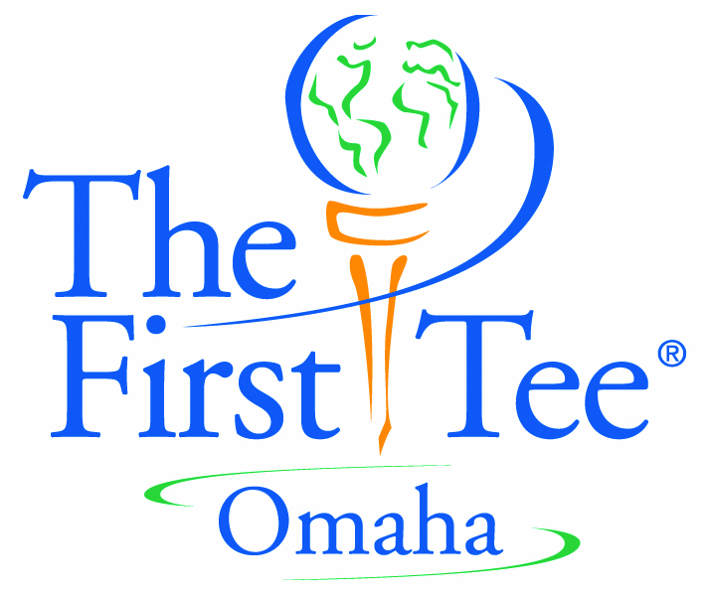*******

Hogan’s Junior Golf Heroes Foundation DBA  
First Tee Omaha

****Founded: 1990 by Steve Hogan, PGA  
  
Board of Directors: Curt Knapp, Board Chair   
 Steve Hogan, Board Vice-Chair  
 Adam Cockerill, Secretary   
 Colin Walker, Treasurer   
 Carl Bartholomew, Past Board Chair   
 Board Members:   
 Dr. Richard Brown  
 Patrick Fay  
 Michael Green  
 Shannon Hite  
 Danette Hogan  
 Brett Michael  
 Mark Morris  
 Cathy Nelson  
 Jerry Pont   
 Matt Studer  
 ** Brian Zaversnik  
  
Staff: Jeff Porter, PGA; Executive Director  
 Taylor Sidzyik; Program, Administration & Team Golf  
 Seth Porter; Program, Administration & Team Golf Amanda Willms & Brandon Williams; Lead coaches  
 (+) 16 seasonal coaches  
  
Overview: Hogan’s Junior Golf Heroes Foundation DBA First Tee Omaha  
 is an “inclusive youth development” program serving Douglas  
 and Sarpy counties.

hon·es·ty

the quality or state of being truthful; not deceptive

Golf is unique from other sports in that players regularly call penalties on themselves and report their own score.

in·teg·ri·ty

strict adherence to a standard of value or conduct; personal honesty and independence

Golf is a game of etiquette and composure. Players are responsible for their actions and personal conduct on the golf course even at times when others may not be looking.

sports·man·ship

observing the rules of play and winning or losing with grace

Players must know and abide by the rules of golf and be able to conduct themselves in a kind and respectful manner towards others even in a competitive game.

re·spect

to feel or show deferential regard for; esteem

In golf it is important to show respect for oneself, playing partners, fellow competitors, the golf course, and for the honor and traditions of the game.

con·fi·dence

reliance or trust. A feeling of self-assurance

Confidence plays a key role in the level of play that one achieves. Players can increase confidence in their abilities by being positive and focusing on something they are doing well regardless of the outcome.

re·spon·si·bil·i·ty

accounting for one’s actions; dependable

Players are responsible for their actions on the golf course. It is up to them to keep score, repair divots, rake bunkers, repair ball marks on the green, and keep up with the pace of play.

per·se·ver·ance

to persist in an idea, purpose or task despite obstacles

To succeed in golf, players must continue through bad breaks and their own mistakes, while learning from past experiences.

cour·te·sy

considerate behavior toward others; a polite remark or gesture

A round of golf should begin and end with a handshake between fellow competitors. Players also should be still and quiet while others are preparing and performing a shot.

judg·ment

the ability to make a decision or form an opinion; a decision reached after consideration

Using good judgment is very important in golf. It comes into play when deciding on strategy, club selection, when to play safe and when to take a chance, the type of shot players consider executing, as well as making healthy choices on and off the golf course.

PHYSICAL:

**ENERGY**

It is important to understand and make healthy choices about when to eat, how much to  
eat, and the types of food and drinks to provide the body with the most useful energy.

**PLAY**

A variety of energizing play can help the body stay strong, lean and fit, and be fun in  
the process. Sleep and other forms of “re-charging” allow one to engage in play on a  
daily basis.

**SAFETY**

Physical safety includes playing in a safe environment and by the rules, protecting the  
body with proper equipment, warm-up and cool-down and wearing sun protection.

EMOTIONAL:

**VISION**

In order to make the most of one’s unique gifts—talents, characteristics and abilities—  
an individual needs to learn from the past, value the present, create their vision and  
future to ultimately “leave a footprint.”

**MIND**

The mind is a powerful tool for health. One’s mind influences his/her emotions and  
behaviors and can be utilized for self-improvement, building confidence and  
maintaining perspective.

**FAMILY**

When family members participate in activities together – share meals, communicate  
and establish roles and responsibilities – they are more likely to be successful in  
achieving their health-related goals.

SOCIAL:

**FRIENDS**

Maintaining healthy relationships includes surrounding one’s self with friends and  
supportive people, while effectively handling challenging situations, including bullying  
and navigating the digital age with social media.

**SCHOOL**

Success in school – learning, building relationships and contributing to the school  
environment – leads to success in other areas of life.

**COMMUNITY**

Like the health of one’s body, it is important to also explore the health of one’s  
community and discover how one can give back and care for its environment and safety.